Analysis, Design & Testing Document
State of New Hampshire
INT_FIN_092 CB Recon – Bank of America
Document Properties
Author | Ritchie Bachini
Creation Date | 06/30/2025
Last Updated | 2/25/2026
Document Reference
Version | 1.5

Document Control

Change Record
1
Date | Author | Version | Change Reference
06/30/2025 | Ritchie Bachini | 1.0 | Initial draft: Executive Summary, Functional Specification, Testing Process
07/09/2025 | Ritchie Bachini | 1.1 | Updated Functional Requirements, business process flow, testing process
07/11/2025 | Lawson Herman | 1.1 | Initial functional Review Completed
7/11/25 | Lila Elizalde | 1.2 | Review and updated- ready for SoNH
07/23/2025 | Ritchie Bachini | 1.3 | Updated using the BOA CB Recon sample file and bank file specs
2/12/2026 | Irie Mack Pable | 1.4 | Updated the navigation and URL links using the consolidated web app roles.
2/25/2026 | Melanie Rose Nunez | 1.5 | Updated the field mapping due to changes in the Cash Management Account code from six leading zeroes to seven.

Contents
1 Document Control 2
1.1 Change Record 2
2 Executive Summary 4
2.1 Business Objectives 4
2.2 Assumptions 4
3 Functional Specifications 6
3.1 Overview 6
3.2 Functional Requirements 6
3.3 Business Process Flow 12
3.4 Field Mapping 13
Technical Specifications 15
3.5 Solution Overview 15
3.6 Technical Configurations 15
4 Testing Process 18
5 Signature 21
5.1 Functional Specification 21
5.2 Technical Specification 21
5.3 Design Sign-off 21
5.4 Testing Sign-off 21
6 Appendix 22

Executive Summary
The State of New Hampshire requires an interface that will automate the process of the file from the Bank of America to Infor FSM for payment reconciliation, when a payment is cleared by the bank (paid) then the status in FSM is to be changed from “open” to “reconciled”. The inbound file will be used primarily to reconcile the cash ledger transactions in the Cash Management module.

Business Objectives
This inbound interface will allow SoNH to automatically reconcile the cash ledger transactions in the “Manage Cash Ledger Transactions” under Cash Ledger Processing. Once the bank reconciliation file is sent to SoNH’s sftp directory, the file will be scanned, and records will be loaded into Cash Ledger Bank Updates Maintenance. Once the records are loaded, IPA will trigger the “Update Ledger Transactions” action to update the status of the cash ledger transactions.

Assumptions
This specification assumes that the following statements are true. Any changes can result in a change order and will be managed using the change order process as defined in the Service Workorder.

- This functional specification defines the complete scope for interface development. Functions not described here are excluded from the deliverables.
- This Bank of America reconciliation inbound interface is applicable only to transactions processed in FSM, and for the bank accounts for which the mapping definitions on this document apply.

- The extract of recon file from Bank of America will be automated and will be placed in the bank’s sftp directory. SoNH to ask the bank’s sftp directory.

- A job will be set to schedule this daily. However, the bank will have capability to manually place the file to the sftp directory on demand.

- Infor FSM will have access to the target directory. SoNH to ensure Bank engagement and involvement for testing.
- Infor FSM and Bank of America test systems are available for testing and development of the interface.
- All setup/configurations applicable to this interface within FSM have been completed.
- Cash code 0054 is the only cash code that will be used for Bank of America reconciliation and cash update.
- Notifications of import to be sent to DEAM, BOA and Treasury.
- Notifications on update process to be sent to DEAM, BOA and Treasury.
- Bank of America will provide the file layout specs which will be mapped to Infor FSM fields.
- Bank recon inbound file will need to be decrypted.

Functional Specifications

Overview
The document can also be described as a “Functional Design Document” which describes the detailed design for Bank of America Cash Ledger Reconciliation interface automation.

Functional Requirements

Functional Requirement ID | Requirement Definition
3.2.1 | Transfer of Bank Recon Input File to SFTP
3.2.2 | IPA Picks up the File in SFTP and reads data from the Input File
3.2.3 | IPA Import to CashLedgerBankUpdate Business Class
3.2.4 | Import Notification – Successful
3.2.5 | Import Notification – Failed and Error Handling
3.2.6 | Update Ledger Transactions
3.2.7 | Notification for Successful Update of Ledger Transactions
3.2.8 | Notification for Update of Ledger Transactions with Error
3.2.9 | Review of Cash Ledger Transactions Status

TRANSFER OF BANK RECON INPUT FILE TO SFTP
Bank of America provided the file layout which will be used to map the bank fields to FSM fields.
The extraction of the reconciliation file from Bank of America and placement to the sftp directory will be automated. However, the bank will be allowed to access and manually place the reconciliation file to the bank’s sftp directory on demand. Infor FSM will be able to retrieve files from bank’s sftp site.

The recon file will be extracted and placed in the sftp directory per bank account or cash management account.

Functional Requirement ID | Requirement Definition
3.2.1.1 | The bank must establish a secure SFTP connection for file transfer.  SFTP Directory: /outgoing
3.2.1.2 | Filename format: NH-TREASURY-DEPT-UC-YB-O.YYMMDDHHMMS.txt

IPA PICKS UP THE FILE IN SFTP and reads data from the input file
IPA automatically picks up files from the SFTP folder location for further processing.
Functional Requirement ID | Requirement Definition
3.2.2.1 | If no file is found, then IPA will not continue.  If a file is found, but the file is empty, IPA will not process the file. IPA will not consider this an error.  If a file is found, bring the file into the IPA.
3.2.2.3 | Once input files are detected in the SFTP directory, IPA will read the input file and transform the file into required FSM CashLedgerUpdate file layout.  The file transformation includes populating the run group and other default required information not present in the bank recon input file.

IPA IMPORT TO CASHLEDGERBANKUPDATE BUSINESS CLASS
IPA will automatically import FSM formatted files into FSM's Cash Ledger Bank Update business class for further processing.
Functional Requirement ID | Requirement Definition
3.2.3.1 | Interface Type Inbound  Source System Bank of America (BOA)  Target System Infor Financials and Supply Management (FSM)  Frequency Once input files are detected  Trigger File existing in designated client SFTP folder  File Location /outgoing  File Name NH-TREASURY-DEPT-UC-YB-O.YYMMDDHHMMS.txt  File Format .txt

IMPORT NOTIFICATION – SUCCESSFUL
IPA will notify the DEAM, BOA and Treasury for the successful import.
To | <!ToRecipientList>
Cc | <!CCRecipientList>
Bcc | <!BCCRecipientList>
From | <!FromEmailAddress>
Subject | [<appProdline>]-WU#<WorkUnit>:NHFIRST - Cash Ledger Bank Update imported successfully.
Body Header | The Cash Ledger Bank Update has been imported successfully.
Body | File Name: <File Name>
Body Footer | This is a system-generated email by Infor Process Flow. Do not reply.    Statement of Confidentiality:The contents of this message and any attachments, if any, may contain confidential or privileged information and are intended for the exclusive use of the addressee(s). Any unauthorized disclosure, reproduction, use or dissemination (either whole or in part) is prohibited. If you are not the intended recipient of this message, please notify the sender immediately and destroy all copies of this message, along with attachments, if any, from your system.

IMPORT NOTIFICATION – FAILED AND ERROR HANDLING
IPA detects import errors and notifies the DEAM, BOA and Treasury.
Functional Requirement ID | Requirement Definition
3.2.5.1 | Automated error detection mechanism for the following:  A. File-Level Errors:  1. Corrupt File – file in sftp is unreadable  2. Unsupported File Format - file in sftp is not in a required format in this document  3. File Name Mismatch – file in sftp is not in a required file naming format in this document  4. Duplicate File – file is imported multiple times, causing redundant data (duplicate can be identified via run group which was already interfaced)  B. Data Validation Errors:  1. Missing Required Fields - A required field is blank.  2. Invalid Data Format - data does not follow the expected format.  3. Truncated Data – Data is cut off due to column size limitations.  4. Reference Data Mismatch – Referenced IDs (e.g., Vendor ID) do not exist in FSM.  5.Mismatched Data Types - data provided does not match data types
3.2.5.2 | A notification configured to alert DEAM, BOA and Treasury distribution group promptly upon error detection. <SONH to confirm>
3.2.5.3 | DEAM, BOA or Treasury to coordinate with the bank to resolve the errors and re-upload fixed files to the bank’s SFTP location for re-processing by IPA. <SONH to confirm>
3.2.5.4 | IPA picks up and re-processes corrected files seamlessly upon re-upload.

To | <!ToRecipientList>
Cc | <!CCRecipientList>
Bcc | <!BCCRecipientList>
From | <!FromEmailAddress>
Subject | [<appProdline>]-WU#<WorkUnit>:NHFIRST - Cash Ledger Bank Update file has import errors.
Body Header | A Cash Ledger Bank Update file for Account <Account Number> has import errors.  Pls check and resubmit files.
Body | File Name: <File Name>  Error File: <Error File Attachment>  Please submit a help desk ticket.
Body Footer | This is a system-generated email by Infor Process Flow. Do not reply.    Statement of Confidentiality:The contents of this message and any attachments, if any, may contain confidential or privileged information and are intended for the exclusive use of the addressee(s). Any unauthorized disclosure, reproduction, use or dissemination (either whole or in part) is prohibited. If you are not the intended recipient of this message, please notify the sender immediately and destroy all copies of this message, along with attachments, if any, from your system.

UPDATE LEDGER TRANSACTIONS
Upon successful import of Cash Ledger Bank Update records, they will be accessible in the Cash Ledger Bank Update Maintenance table under the CashLedgerBankUpdate business class. IPA will then initiate an interface action and run the Update Ledger Transactions for a run group in the input file and check the results.
Navigation: Cash > Cash Ledger > Processing tab > Process section > Bank Update Maintenance

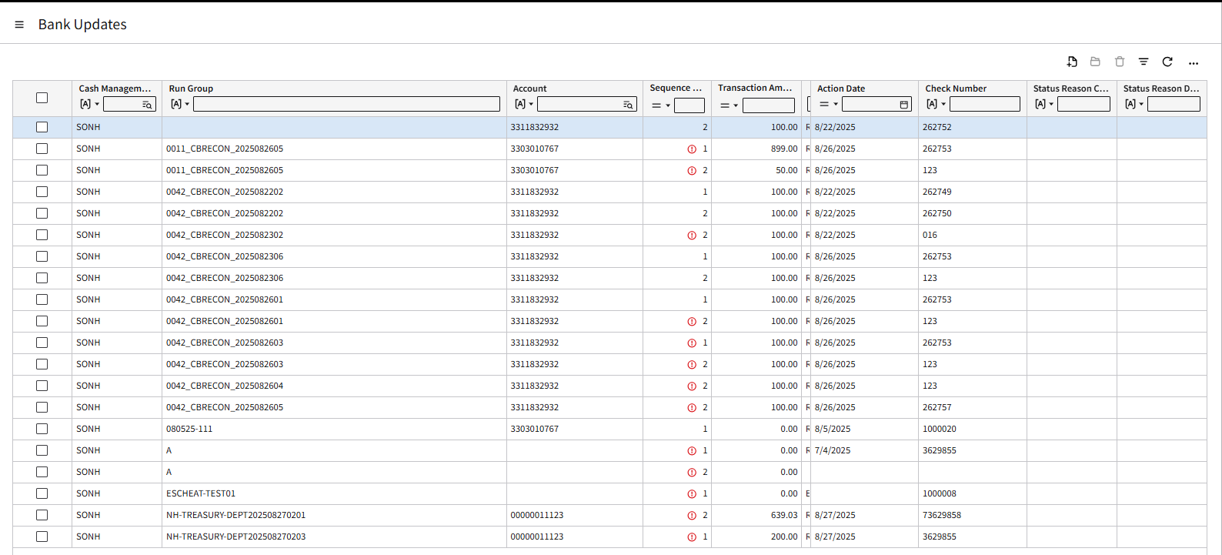

Functional Requirement ID | Requirement Definition
3.2.6.1 | Please take note of the following parameters:  Field Value Required  Cash Management Group “SONH” Yes  Run Group NH-TREASURY-DEPT-UC-YB-O.YYMMDDHHMMS Yes  Ignore Duplicate Check Numbers Uncheck No  Bank Account Number Leave <blank> No  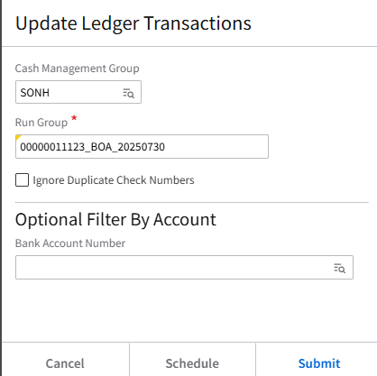
3.2.6.2 | Successful update will result in Cash Ledger Transactions with status “Reconciled” or the status name as indicated in reconciliation file.
3.2.6.3 | Error Handling:  At the end of the process, IPA will send an email to the end user telling them the file/run group name, number of records, and whether errors were encountered.  In cases where errors are encountered during the bank update process, Treasury <SONH to confirm> needs to check the errors via Cash > Cash Ledger > Processing tab > Process section > Bank Update Maintenance and resolve the error.  After correcting the error, the Treasury must manually run the Update Ledger Transactions to update the Cash Ledger transactions that went into error.  

NOTIFICATION FOR SUCCESSFUL UPDATE OF LEDGER TRANSACTIONS
IPA will notify the DEAM, BOA and Treasury for the successful update.
To | <!ToRecipientList>
Cc | <!CCRecipientList>
Bcc | <!BCCRecipientList>
From | <!FromEmailAddress>
Subject | [<appProdline>]-WU#<WorkUnit>:NHFIRST – Successful Update of Cash Ledger Transactions
Body Header | The Update of Cash Ledger Transactions for Run Group <Run Group> was successful.
Body | File Name: <File Name>  Run Group: <Run Group>  No. of Records: <No.of Records>  Work Unit: <WorkUnit>
Body Footer | This is a system-generated email by Infor Process Flow. Do not reply.    Statement of Confidentiality:The contents of this message and any attachments, if any, may contain confidential or privileged information and are intended for the exclusive use of the addressee(s). Any unauthorized disclosure, reproduction, use or dissemination (either whole or in part) is prohibited. If you are not the intended recipient of this message, please notify the sender immediately and destroy all copies of this message, along with attachments, if any, from your system.

NOTIFICATION FOR UPDATE OF LEDGER TRANSACTIONS WITH ERROR
IPA detects the errors and notifies DEAM, BOA and Treasury. <SONH to confirm distribution group>
Functional Requirement ID | Requirement Definition
3.2.7.1 | A notification configured to alert agency distribution group promptly upon error detection.
3.2.7.2 | Real-time detection of update errors within FSM. Upon update of the ledger transactions per run group, the remaining records in the CashLedgerBankUpdate business class contain error messages.
3.2.7.3 | Treasury resolves the error/s manually and re-runs the Update Ledger Transactions until the records are completely updated.

To | <!ToRecipientList>
Cc | <!CCRecipientList>
Bcc | <!BCCRecipientList>
From | <!FromEmailAddress>
Subject | [<appProdline>]-WU#<WorkUnit>:NHFIRST - Update of Cash Ledger Transactions With Error
Body Header | The Update of Cash Ledger Transactions for Run Group <Run Group> encountered an error. Please correct the error manually and re-run the Update Ledger Transactions.
Body | File Name: <File Name>  Run Group: <Run Group>  No. of Records: <No.of Records>  No. of Successful Records: <Total No.of Records less No.of Records with Error>  No. of Failed Records: <No.of Records with Error>  Work Unit: <WorkUnit>  <Link to Cash Ledger Bank Update Maintenance>  Please submit a help desk ticket.
Body Footer | This is a system-generated email by Infor Process Flow. Do not reply.    Statement of Confidentiality:The contents of this message and any attachments, if any, may contain confidential or privileged information and are intended for the exclusive use of the addressee(s). Any unauthorized disclosure, reproduction, use or dissemination (either whole or in part) is prohibited. If you are not the intended recipient of this message, please notify the sender immediately and destroy all copies of this message, along with attachments, if any, from your system.

Navigation: Cash > Cash Ledger > Processing tab > Process section > Bank Update Maintenance



REVIEW OF CASH LEDGER TRANSACTIONS STATUS
Successful update of cash ledger transactions in FSM marks the completion of the process and checks the status of the Cash Ledger transactions as indicated in the bank reconciliation file.
Cash > Cash Ledger > Processing tab > Process section > Transactions > All Transactions tab > Filter Bank Transaction Code or Status
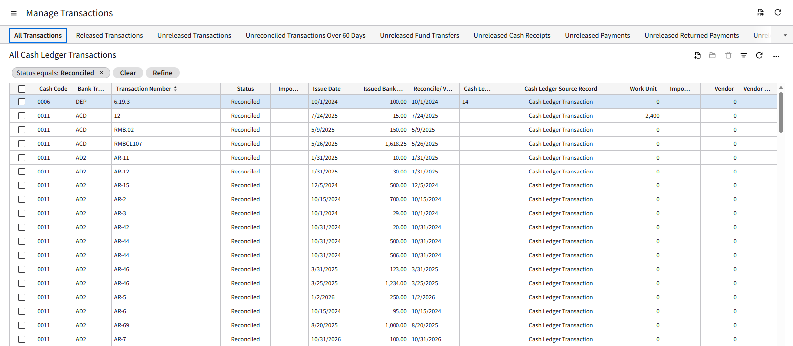

Business Process Flow

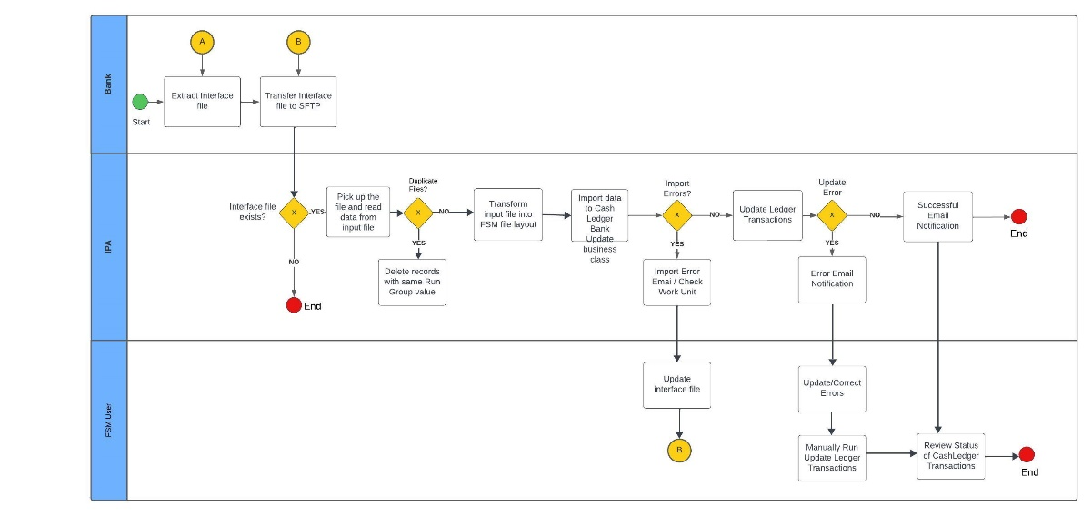

Field Mapping
The Bank of America provided a bank file layout in fixed length which will be used by FSM to create the import file CashLedgerBankUpdate Business Class.
The fields below from the detail record of the bank file layout, highlighted in red, will be used to map to FSM fields.

Bank of America File Layout
Sample Detail Record:
0000000111230000003629912P000003200001216251216250000000000B2222268WD 094560736
Position | Length | Bank Field | Type | Bank  Sample Value | Remarks
Detail Record
1-12 | 12 | Account | Num | 000000011123
13-15 | 3 | Subaccount | Num | 000
16-25 | 10 | Serial number | Num | 0003629912 | Right justified, left zero filled
26-26 | 1 | Status | Alpha | P
27-37 | 11 | Amount | Num | 00000320000 | Right justified, left zero filled
38-43 | 6 | Paid Date | Alpha (MMDDYY) | 121625
44-49 | 6 | Issue Date | Alpha(MMDDYY) | 121625
50-54 | 5 | Batch Number | Num | 00000
55-59 | 5 | Sequence Number | Num | 00000
60-71 | 12 | Reference Number | Alpha | B2222268WD
72-80 | 9 | Item Sequence Number | Num | 094560736
81-81 | 1 | Record Type | Alpha | <blank>
Total Record
1-12 | 12 | Account | Num | 000000011123
13-15 | 3 | Subaccount | Num | 999
16-25 | 10 | Serial Number | Num | 9999999999
26-31 | 6 | Control Date | Alpha (MMDDYY) | 250313
32-40 | 9 | Paid Count | Num | 000000548
41-51 | 11 | Paid Amount | Num | 00378839284
52-60 | 9 | Advance Paid Count | Num | 000000001
61-71 | 11 | Advance Paid Amount | Num | 00000096929
72-81 | 10 | Filler | Alpha | <blank>

Field Mapping

FSM Field | Type | Field Size | Required Field? | Remarks | FSM  Sample Value | Bank Field
CashLedgerBankUpdate Business Class |  |  |  |  |  | Note: Use the Detail Record fields above highlighted in red
CashManagementGroup | AlphaUpper | 4 | Yes | Default value of "SONH" | SONH
RunGroup | AlphaUpper | 30 | Yes |  | NH-TREASURY-DEPT.YYMMDDHHMMSS | File Name
CashManagementAccount | AlphaUpper | 35 | Yes |  | 000000011123 | Account
SequenceNumber | Numeric | 10 | Yes | IPA to assign sequence number based on the detail record sequence | 1
TransactionAmount | Decimal | 16.2 | No | With 2 decimal places | 3200.00 | Amount
CashLedgerUpdateAction | Numeric | 2 | Yes | If status of bank =”P”, mark update action as  6 = “Reconciled” | 6 | Status
ActionDate | YYYYMMDD | 8 | Yes | Need to transform the date format from the bank field from MMDDYY to YYYYMMDD | 20251216 | Paid Date
CheckNumber | AlphaUpper | 22 | Yes |  | 3629912 | Serial Number
CashCode | AlphaUpper | 20 | No | FSM Cash Code Associated with eh Account Record  CashCode.CashCode where CashCode. BankAccountNumber = CashLedgerBankUpdate.CashManagementAccount  E.g.  0054 = BOA Vendor Controlled Disburse | 0054
BankTransactionCode | AlphaUpper | 10 | No | Default value of “CHK” | CHK

Technical Specifications

Solution Overview

Technical Configurations

File Channel
Configure a file channel to monitor for any incoming source files for processing. The process and error directory contents will be stored in the file storage. A single work unit will be created for each source file.
See Infor Landmark Technology Administration Guide and Infor Process Automation Administration Guide for CloudSuite for more detailed information on administration of file channels and receivers.

File Channel Setup
Channel Name
Description
Enabled
File Channel Type
Source File Directory
File Match Case Sensitivity
Error File Directory
In-progress File Directory
File Scan Interval in Minutes

File Transfer Connection
Host | sftp.inforcloudsuite.com
Protocol | SFTP
User
Password
* For security purposes, request for the UserName & Password from your System Administrator.

File Receiver Setup
Channel Name
Receiver
Description
File Name
Ignore Delete Errors
ProcessFlow
Data
Startup Type

Process Flow Design

System Configuration Setting

Configuration: fsm

Properties
Property Name | Description | Value

File Transfer Connection
Host
Protocol
User
Password
File System
* For security purposes, request for the UserName & Password from your System Administrator.

Process Flow: SoNH-INT-FIN-092

Trigger
This process flow is triggered via File Channel.

Variables

Testing Process
Initial testing will be conducted without actual transmission of files from Bank of America.
Once validation of the file format is completed, actual testing with the Bank of America will follow.

TRANSFER OF RECONCILIATION File to SFTP

Scenario | Expected Result
Verify SFTP file transfer | File successfully transferred to SFTP
Verify that the file appears in the correct directory of the SFTP server. | The file should be visible and accessible in the designated directory.

IPA PICKS UP THE FILE IN SFTP AND READS THE INPUT FILE
Scenario | Expected Result
The transferred CashLedgerBankUpdate layout file from the bank in the SFTP location monitored by IPA. | IPA should detect and pick up the file from the SFTP location.
Trigger IPA’s automated process to pick up the file. | The automated process should be executed within the defined timeframe.
Verify that IPA detects and retrieves the file within the expected timeframe. | Confirmation in SFTP directory that the file retrieval event is recorded and archived.

IPA IMPORT INTO CASHLEDGERBANKUPDATE BUSINESS CLASS
Scenario | Expected Result
Trigger the automated loading process for a transformed file into FSM. | IPA should successfully load the transformed data into the CashLedgerBankUpdate business class.
Verify that FSM validates and loads the data into the CashLedgerBankUpdate business class. | Validation checks should ensure data accuracy and completeness.
Check data integrity by reviewing loaded records against expected content and format. | Review of loaded records should match the expected content and format in FSM.

IMPORT ERROR DETECTION AND NOTIFICATION
Scenario | Expected Result
Introduce a deliberate error into an FSM layout file processed by IPA. | IPA should detect deliberate errors during processing.
Trigger the processing and verify that IPA detects the error. | Processing should stop upon error detection to prevent incorrect data integration.
Confirm that IPA halts processing and notifies the distribution group. | A timely notification should be sent to the designated distribution group with details of the error.

IMPORT ERROR RESOLUTION AND RE-PROCESSING
Scenario | Expected Result
Identify an error in an FSM layout file and resolve it offline. | The identified error should be resolved correctly in the FSM layout file offline.
Re-upload the fixed file to the SFTP location monitored by IPA. | IPA should detect the re-uploaded fixed file and initiate re-processing automatically.
Verify that IPA picks up the fixed file and successfully re-processes it. | Confirmation that the re-processed file integrates successfully without errors.

IPA UPDATE OF CASH LEDGER TRANSACTIONS
Scenario | Expected Result
IPA automatically run Update Ledger Transactions using the Run Group within CashLedgerBankUpdate business class. | The IPA should automatically run the Update Ledger Transactions using the Run Group to the CashLedgerBankUpdate business class.
Record Count Verification | Ensure that all records from the source file are successfully imported without missing any data. The number of records in the target system should match the number in the source file.
Reference Data Consistency – Valid Data | The system should successfully import all records with valid reference data. No errors or warnings should be generated for these records.
Reference Data Consistency – Invalid Data | The system should reject or flag records with invalid reference data.

UPDATE HANDLING IN FSM AND USER ERROR RESOLUTION
Scenario | Expected Result
Introduce a full error run group deliberately and trigger error detection within FSM. | FSM should detect all records in error. All failed records in the run group remain the CashLedgerBankUpdate business class.
Introduce a partial successful and failed records deliberately and trigger partial update and error detection within FSM. | FSM should update ledger transactions for those successful records and remove them from the CashLedgerBankUpdate business class.  FSM should detect those records in error which remain in the CashLedgerBankUpdate business class and show the error message per record.
Manually fix the identified errors in FSM. | Manual fixes should be applied successfully and can rerun the Update Ledger Transactions action.
Confirm that IPA notifies the distribution group. | A timely notification should be sent to the designated distribution group showing the number of successful and failed records and a link to the Cash Ledger Bank Update Maintenance.
Review the status of Cash Ledger transactions for partial successful records. | The status of the Cash Ledger transactions for those partial successful records should match the CashLedgerUpdateAction as indicated in the bank reconciliation file.

COMPLETION OF PROCESS AND NOTIFICATION OF SUCCESSFUL UPDATE
Scenario | Expected Result
Ensure that all records intended for updating are successfully processed within CashLedgerBankUpdate business class. | All records intended for updating should be processed successfully within FSM.
Trigger a successful update process. | IPA should send a notification promptly upon successful update of cash ledger transactions.
Verify that IPA sends a notification to the distribution group confirming successful update. | The notification should confirm the successful update of cash ledger transactions.
Review the status of Cash Ledger transactions | The status of the Cash Ledger transactions should match the CashLedgerUpdateAction as indicated in the bank reconciliation file.

Signature
By signing this document both Infor and SoNH agree and confirm their acceptance of information contained within this specification which encompasses detailed business processes, requirements, scope and solution design.

Functional Specification

Project Sponsor | Name | Position | Date | Signature
<Client> | Treasury, DEAM, BOA
Infor | Ritchie Bachini | Consultant | July 9, 2025

Technical Specification

Project Sponsor | Name | Position | Date | Signature
<Client>
Infor

Design Sign-off

Project Sponsor | Name | Position | Date | Signature
<Client>
Infor

Testing Sign-off
Project Sponsor | Name | Position | Date | Signature
<Client>
Infor

Appendix
Bank specifications provided:

